Cognitive Science Fundamentals

# Table of contents

Table of contents 2

Terms & Definitions 6

General, overencompassing 6

➢ Cognitive Psychology, neuroscience vs cognitive science 6

➢ Cognitive Science 6

➢ Ecological validity 7

➢ Entropy 7

➢ Artificial Intelligence 7

Attention 8

➢ Selective attention 9

➢ External attention 9

➢ Internal attention 9

➢ Attentional bias 9

➢ Attentional training technique 9

➢ Decoupling (attention) 10

➢ Inattentional blindness, dup 10

➢ Change blindness 10

➢ Attentional Blink 10

➢ Covert attention 10

➢ Overt attention 10

➢ Spatial attention 11

➢ Vigilance 11

➢ Modulation of attention 11

➢ Visual attention 11

➢ Auditory attention 11

➢ Top-down attention 11

➢ Bottom-up attention 11

➢ Feature-based attention 12

Exogenous attention 12

Endogenous attention 12

➢ Dichotic listening task 12

➢ Cocktail party effect 12

Perception 13

➢ Frequency 14

➢ Pitch 14

Timbre 15

➢ Tritone paradox 15

➢ Basilar tuning 15

➢ Binding problem 15

➢ Bottom-up processing 16

➢ Top-Down processing 16

➢ Inattentional blindness, dup 16

➢ Intensity 16

➢ Interoceptive senses 16

➢ Low-level descriptor (auditory perception) 16

Metacognition 17

➢ Bayesian inference 17

➢ Phase locking (sound) 15

➢ Phenomenal stability (vision) 17

➢ Pitch (Fundamental frequency) **Error! Bookmark not defined.**

➢ Rubber Hand Illusion 17

➢ Saccade 18

➢ Saccadic suppression 18

➢ Space constancy (vision) 18

➢ Acoustic signal 18

➢ Fovea 18

➢ Fourier analysis 18

➢ Fixation 18

➢ Exteroceptive senses 18

➢ Corollary discharge 18

➢ Complex tone 18

➢ Chemoreceptive senses 18

➢ Teloreceptive senses 18

➢ Proprioceptive senses 18

➢ Amplitude (sound) 14

➢ Acoustic feature 18

Memory 18

Sensory Memory 18

Short term memory 18

Baddeley's model of working memory 18

Central executive 18

Phonological loop 18

Visual-spatial sketch pad 18

Episodic buffer 18

Long-term memory 18

Implicit memory 18

Procedural memory 18

Declarative memory 18

Semantic memory 18

Episodic memory 18

➢ Familiarity 18

➢ Feeling of knowing 18

➢ Recollection 18

➢ Metamemory 18

➢ Cued recall 18

➢ Serial position curve (memory) 18

➢ Primacy effect (memory) 18

➢ Recency effect (memory) 18

➢ Reinforcement Learning 18

➢ Amnesia 18

State dependency (memory) 18

➢ Type I processing (memory) 18

➢ Type II processing (memory) 18

➢ False memories 18

(Brain) anotomy 18

Link to CC video on CNS (from limbic system on) 18

➢ The Cerebrum → 18

➢ Frontal lobe 18

Prefrontal cortex 18

➢ Temporal lobe 18

➢ Occipital lobe 18

➢ Parietal lobe 18

The Limbic system 18

Thalamus 18

➢ Primary auditory cortex 18

➢ Cochlea 18

➢ Retina 18

➢ Blind spot 18

➢ Basilar membrane 18

Terms from papers (which are more extended) 18

Executive functions 18

Shifting 18

Updating 18

Inhibition 18

Metacognition , dup 18

Active sampling (attention) 18

Ensemble perception 18

Short term memory ; slot model vs equal resource model 18

the hippocampus and recollective memory organization 18

Pop quizzes 18

Difference mechanism visual auditory attention 18

Active sampling 18

Hubel and wiesel 18

Pitch 18

Metacognition , dup 18

Executive functions 18

Phonological Loop and the VSSP 18

Other important information 18

The cognitive system schematic 18

Memory stores schematic 18

Familiarity vs recollection ; dpsd and cdp models 18

# Terms & Definitions

## General, over encompassing

### Cognition

**Def** simple wiki: Cognition is the scientific word for the thought process. This process is the way we think. The word comes from the Latin word cognoscere, which means "to know" or "to recognize". Cognitive psychology is the science which studies cognition.

**Def** wiki: the mental action or process of acquiring knowledge and understanding through thought, experience, and the senses".[1] It encompasses many aspects of intellectual functions and processes such as attention, the formation of knowledge, memory and working memory, judgment and evaluation, reasoning and "computation", problem solving and decision making, comprehension and production of language. Cognitive processes use existing knowledge and generate new knowledge.

### Cognitive Science

* + Cognitive science is the scientific study of the mind and mental processes and **incorporates many fields** like philosophy, psychology, technology, neuroscience, and anthropology. →
  + Understanding/studying **how we come to know** things
  + Simply put: Cognitive Science is the interdisciplinary study of cognition in humans, animals, and machines
  + 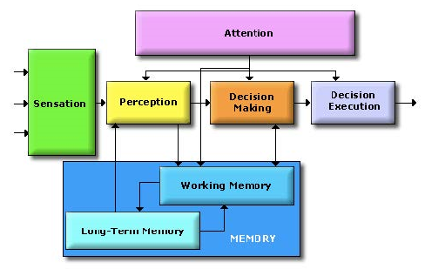Cognitive scientists study intelligence **and behavior**, with a focus on how **the nervous systems** represent, processes, transforms, stores and recoveres information.
  + Mental faculties of concern to cognitive scientists include **language, perception, memory, attention, reasoning, and emotion**
  + The cognitive system schematic →
  + Immanuel Kant
    - Sensation is organized stimuli
    - Perception is organized sensation
    - Conception is organized perception
    - Science is organized conception

### Differences: Cognitive Psychology, neuroscience vs cognitive science

* + Cognitive psychology is more focused on **information processing (mainly attention, perception, memory) and behavior**.
  + Cognitive neuroscience studies the **underlying biology** of information processing and behavior.
    - Also likes to use **measuring devices** like FMRI
  + Differences:
    - Cognitive science is concerned with the changes occurring in the **nervous system** when an individual performs some high level cognitive function. It aims at studying how different parts of the brain work in tandem to produce a particular reaction to a given stimulus. The field is more research based.
    - Psychology on the other hand deals with people with feelings and does **not look at them as research objects only**. It is more interventional in nature. It helps people to work on their thinking to improve their behaviour in society.
      * Seems to be more applied science in nature

### Ecological validity

* + Methods, materials and setting of the study must approximate the real-world that is being examined.

### Entropy (rt active sampling)

* + Measure of disorder of a system
    - Entropy = 0 → completely homogeneous sample
    - Entropy = 1 → Sample is equally divided
    - 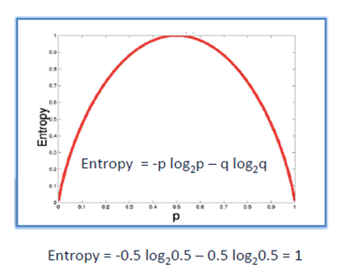

### Artificial Intelligence

* + Intelligence, not manifested by an organic machine (but by a mechanical one)

## Attention

**keywords**:

Selection

Limited_mental_resource

Ignoring

def tb; the selection of a subset of information for further processing by another part of the information processing system

def; The process of focusing limited mental resources on the information and cognitive processes that are most salient at a given moment”

def; selectively concentrating on a discrete aspect of information, while ignoring other perceivable information.

BASIC CHARACTERISTICS:

Limited Capacity

Selection

Modulation ; The act of modifying or adjusting?

Vigiliance ; attention is sustainable if necessary?

link with the executive functions sa inhibition? yes...

* + Types of attention:
    - Active/top-down (controlled by individuals goals) VS. Passive/bottom-up (Controlled by external stimuli)
    - Focussed(selective - sustained) VS. Divided(Multitasking)
    - Internal(internal processes; endogenous) VS. External (external stimuli; exogenous)
  + Alternative definitions:
    - Attention acts as the means of focussing limited mental resources on the information and cognitive processes that are most salient at a given moment. - Sternberg 1999
    - Attention is a mental process that requires mental resources to direct and focus mental resources. These mental resources are limited; the more attention a task requires, the less remains for performing other tasks.

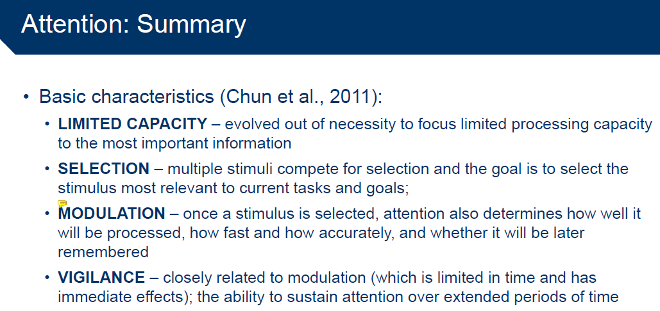

### Selective attention

* + may be defined as a process by which the perception of certain stimuli in the environment is enhanced relative to other concurrent stimuli of lesser immediate priority
  + psychological theories of selective attention were traditionally divided between:
  + **Early selection theories** ; those advocating early levels of stimulus selection
  + They held that there was an early filtering mechanism by which “channels” of irrelevant input could be attenuated or even rejected from further processing based on some simple physical attribute
  + Sensory register → selective filter → perceptual processes → other cognitive processes
  + Problem: if one completely filters out unattended info before it gets assigned meaning, one should not be able to hear one’s own name, when it’s spoken in the unattended ear; E.G.( cocktail party effect) and those advocating **late selection** held that all stimuli are processed to the same considerable detail, which generally meant through completion of perceptual analysis, before any selection due to attention took place
  + Sensory register → perceptual processes → selective filter →[1] other cognitive processes

### External attention

* + Selection and modulation of sensory information
    - Selects locations in space & time, or modality[2]-specific input
    - Feature-based or object-based
    - Integrations of objects/features over space, time and modality

### Internal attention

* + Selection, modulation and maintenance of internally generated information
    - High-level cognitive
      * Mental processes
        + Thoughts
        + Plans
        + Rules & responses
        + Self-monitoring
        + Memories
    - Low-level cognitive
      * Bodily functions
        + Pain
        + Hunger
        + etc.

### Attentional bias

* + The tendency for people's perception to be affected by their recurring thoughts at the time
    - e.g. pain, positive emotions regarding validation
  + may explain an individual's failure to consider alternative possibilities, as specific thoughts guide the train of thought in a certain manner.
  + Distinct from confirmation bias? ; The tendency to search for, interpret, focus on and remember information in a way that confirms one's preconceptions

### Attentional training technique

* + **Meta-cognitive treatment** strategy used to remediated self-focussed proccessing and to **increase attention flexibility**
  + in some instances have significant beneficial effects on anxiety and depression when practiced in its own right
  + The technique consists of **actively listening and focusing attention** in the context of **simultaneous sounds presented at different loudness and spatial locations**
  + In order for ATT to work we have found that regular and consistent practice of the technique is necessary. The effects appear to develop with time and we advise that it is practiced twice a day for an initial period of 4 weeks during the course of treatment

### Decoupling (attention)

* + Similar to states such as daydreaming or absented mindwandering
    - e.g. mind decouples attention from primary task and engages in mind wandering

### Inattentional blindness, dup 1

* + A stimulus is not perceived even when the person is looking directly at it.
  + Looking at things doesn’t guarantee seeing them → pay attention
    - E.G.( the gorilla and basketball )
  + Examples: Change Blindness, Repetition Blindness, Visual Masking & Attentional Blink
* Distinctions
  + Inattentional blindness is related to but distinct from other failures of visual awareness such as change blindness, repetition blindness, visual masking, and attentional blink. The key aspect of inattentional blindess which makes it distinct from other failures in awareness rests on the fact that the undetected stimulus is unexpected

### Change blindness

* + The phenomenon of the inability of participants to notice gross changes in the environment that occur while attention is diverted.
  + Brain tends to focus on the meaning of the scenes, rather than on the details
  + [Experiment](https://youtu.be/VkrrVozZR2c?t=125) : breaking op questioner from the questionee
    - Roughly **50 %** don’t notice the change
    - Conjecture:
      * A Person **encodes what is relevant to them**: giving directions | don’t pay attention to details that are irrelevant: color short, exact height of person
      * People make sense of meaning of the scene and **main categories**, tall/short, age, sex, race ; as long as these don’t change, the **meaning of the scene** stays the same

### Attentional Blink

* + Within a rapid succession of stimuli, the perception of a predefined target often impedes the observer’s ability to detect another stimulus that is presented close in succession(180-450 ms)
  + Factors
    - Context
    - Stimulus saliency(=importance/priority)
    - Observer’s goals

### Covert attention

* + Sheets: internal shift of attention, in conditions where there is no time for eye movements.
  + Internal:
    - Attention directed/shifts to internal/mental processes, no behavioural manifestation
    - Resolving internal selection conflicts concerning processing resources
  + External:
    - VIsually: attending to objects of interest in the visual scene without shifting gaze to them
  + Improves the detection and discrimination(or categorisation of salience) of stimulus features at a given location

### Overt attention

* + Sheets: overt movement of head and/or eyes
  + Attention directing/shifting to behavioural manifestation
    - e.g. eye & head movement, track object or sound, motor coordination

### Spatial attention

* + Directing your attention to a location in space
  + Mostly auditory & visual

### Vigilance

* + The ability to sustain attention over an extended period of time
  + 1 of 4 main **characteristics of attention** next to: limited, selective, modulation
    - Vigilance (like active search, selective attention, and divided attention) is a type of attention. These types of attention are often described as main functions rather than subfunctions of attention.
    - Closely related to modulation (which is limited in time and has immediate effects)
      * Basically the ability to modulate your attention on/for a specific stimulus/information source for an extended period of time

### Modulation of attention

* + Once a stimulus is selected, attention also determines:
    - how fast and
    - how accurately,
    - and whether it will be remembered later
    - how well it will be processed,

### Visual attention

* You Cannot take in all visual information for processing at once → You Shift visual attention around the environment to focus on important information sources
  + Spotlight metaphor
  + Space-based model of attention (Directed to one physical part of environment at any given)

### Auditory attention

* Auditory information is received simultaneously → no ‘spotlight’ like eyes
  + Auditory information selection is done by sensory processing, not directing the senses

### Top-down attention

* + Top-down processing:
    - **Existing knowledge** applied on **sensory** stimuli to create **perception**
    - Neural correlates:
      * Increased firing rates of neurons encoding the attending stimulus (modulation)
      * Reduced variability(or increased consistency) of responses to repeated stimuli → less noise in the signal
      * Reduced [covariability](https://en.wikipedia.org/wiki/Covariance)(smaller mismatch) of neuronal responses to repeated stimuli in simultaneously recorded neurons → reduced redundancy in the signal
        + [covariability](https://en.wikipedia.org/wiki/Covariance)

### Bottom-up attention

* + **Stimulus-driven** attention/exogenous attention
  + Attentional processing is driven by the **properties of the objects themselv**es.
    - Attention is drawn automatically: We don’t get to choose whether we want to attend to these stimuli or not
    - e.g. loud noise, bright light
  + Global salience is computed/amplified within the parietal cortex or PFC

### Feature-based attention

* + Directing senses to a particular feature(scan for: house number, person’s voice in crowd, reading braille)

### Exogenous attention

* + Attention that is drawn **automatically** to a stimulus without the intention of the participant. Processing by exogenous attention **cannot be ignored**. It is attracted, for example by a **peripheral** cue, in visual orienting experiments. Stimulis driven, **top down**.

**Characteristics:**

* + Pop out effect
  + exogeneous cue
  + **Cues** that are external to any goals we might have , we don't have to tell ourselves to attend to them, its automatic ; like bright light, loud noise.
  + Cannot be ignored

### Endogenous attention

* + Attention that is internally driven top - down;
  + endogenous cue
    - Cues that are more internalized and higher order, involve internal knowledge to understand the cue in the first place (like an arrow[3])

### Cocktail party effect

* + The cocktail party effect is the phenomenon of the brain's ability to let you focus your auditory attention (an effect of selective attention in the brain) on a particular stimulus while **filtering out** a range of other stimuli.
  + Listeners have the ability to both **segregate** different stimuli into different streams, and subsequently decide which streams are **most relevant** to them.
  + as when a partygoer can focus on a single conversation in a noisy room
  + Thus, it has been proposed that one's sensory memory subconsciously **parses stimuli**, for classifying them by **salience**.
  + This effect is what allows most people to "tune into" a single voice and "tune out" all others.
  + It may also describe a similar phenomenon that occurs when one may immediately detect words of importance originating from unattended stimuli, for instance hearing **your name** among a wide range of auditory input (**across the dinner table**, while one was attending to a different conversation)

### Dichotic listening task

* + Different auditory message is presented to each ear and attention has to be directed to one message
    - Participant is asked to ‘on-line/live’ shadow/repeat one of the message
    - Participant is asked about message of unattended ear
      * Only physical characteristics of unattended message could be reporte

## Perception

**Def**  tb ; The most general meaning of the term perception is sensory processing

When thinking about perception you have to think about **sensation**:

Sensation is the **BOTTOM-UP** process by which our senses receive and pass along outside stimuli

**Def** CC on SENSES: The **bottom-up process** by which our senses receive & pass along outside **stimuli**

**Def** CC: The **top-down** way[4] our brains organize & interpret **That** information & put it into **context**

**def**  Kant; perception is organized sensation (sensation is organized stimuli)

**def** wiki; the organization, identification, and interpretation of **sensory** information in order to represent and understand the presented information, or the environment.

Definitions of perceptions as a **constructivist approach** , which is more **top-down** based

* Gregory (1998) follows ideas originally proposed by Helmholz, that ‘perception is intelligent decision-taking, from limited sensory evidence . . . perceptions are hypotheses of what may be out there’
* ecological approach to perception
  + Has been rejected, since the approach cannot easily explain how different affordances arise depending on the perceiver’s current goal or needs, or the effects of context.

### SOUND→→→

### Frequency

* **Def** tb; In acoustics, the period of the sine wave that gives rise to the psychological property of pitch
* **Physical property** of sound, next to amplitude & comlexity
* When speaking about the frequency of a sound, it means the property that most determines **pitch**
* Higher & lower frequency, how it influences pitch → [**Higher**](https://youtu.be/qNf9nzvnd1k?t=43) **frequency = higher pitch**
  + It may help to think of low, middle and high-frequency sound with respect to musical notes. The **lowest** note on musical instruments like organs, tubas, pianos and cellos are all in **the 5-70 Hz** frequency range. **Middle** C in the treble clef of a piano is a medium sound frequency sound, just a little above **500 Hz**. The highest note on a flute is at the low end of high-frequency range, about 2100 Hz, while the highest note on a standard piano is a little over 4000 Hz. In terms of your stereo, when you turn up the bass, you’re filtering out the high-frequency sound and getting more low-frequency sound, and when you turn up the treble you’re getting more of the high frequencies.

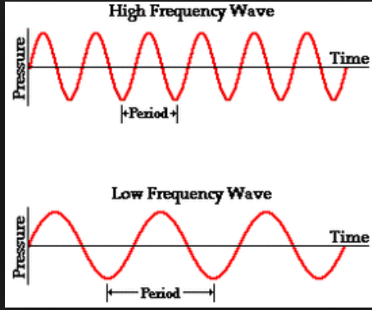

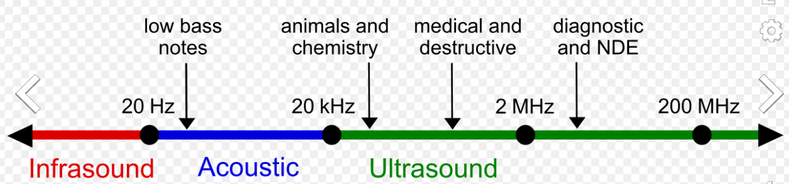

### Pitch

* + Pitch is the **perceptual/psychological property** of the fundamental/physical property of sound: frequency .
  + Perceptual/psychological
  + For humans, it is an important source of information about a speaker’s age, gender and expected size.
  + Higher & lower frequency, how it influences pitch → Higher frequency = higher pitch

### Amplitude (sound)

* 2. Peak amplitude
  3. Peak-to-peak amplitude
  4. Root mean square amplitude
  5. [Wave period](https://en.wikipedia.org/wiki/Wave_period) (not an amplitude)

### Timbre

* + Spectral content of a sound; what distinguishes two sounds that are equal in **loudness, pitch and duration**
  + Timbre is th reason why instruments playing ‘the same tone’ sounds different
  + Link to yt [vid](https://youtu.be/VRAXK4QKJ1Q?t=19): constant 127 hz & constant duration, yet sounds very different

### Tritone paradox

* The basic pattern that produces this illusion consists of 2 tones that are related by a half-octave. (This interval is called a tritone). When one tone of a pair is played, followed by the second, **some people hear an ascending** pattern. But **other people, on listening to the identical pair of tones, hear a descending pattern instead.** This experience can be particularly **astonishing to a group of musicians who are all quite certain of their judgments, and yet disagree completely as to whether such a pair of tones is moving up or down in pitch.**

Shepard illusion

* Link to [yt vid](https://youtu.be/RQlrSvnG3dg?t=18)

### Fourier analysis

* + Fourier analysis is Used to analyse the component sine waves from the wave form of a complex sound.

### Basilar tuning

* + The hairs in the cochlea can contract and dilate making it able to have a sort of focussing/filter effect to listen for the particular sound/source you’re interested in
    - This would be a similar effect to direct the fovea of the eye to an object of interest

### Phase locking (sound)

* + Spikes in the auditory nerve tend to occur at a given phase in the cycle of a stimulating waveform producing a precise relationship between the waveform & the timing of the spikes, so-called PHASE LOCKING

### The [Binding problem](https://youtu.be/9oR8tB4u3Yk?t=81)

* **Def** The problem: how all the different **perceptual properties** are correctly put together, into the correct combination, when the processes is divided by division of labour by so many different specialized neurons, pathways & brainregions; **the problem: how does the brain know to process them into the same objects?**
* **Def** : Properties of the visual world are coded by specialised cells, pathways and brain regions. The problem that arises from this division of labour is how attributes belonging to the same object
* There are 2 components to the binding problem:
  + Segregation problem:

practical computational problem of how brains segregate elements in complex patterns of sensory input so that they are allocated to **discrete “objects**”.

* + - E.g. When looking at a blue square and a yellow circle, what neural mechanisms ensure that the square is perceived as blue and the circle as yellow, and not vice versa?
  + Combination problem:

The problem of how objects background and abstract or emotional features are combined into a single **experience**.

### Bottom-up processing

* + Related to **Sensory** input
  + Neural correlates: pop out stimuli drive attention automatically
  + characterized by an absence of higher level direction in sensory processing
  + E.G.( Cognitively speaking, certain cognitive processes, such as **fast reactions** or quick visual identification, are considered bottom-up processes because they rely primarily on sensory information )
  + E.G.( If your attention is drawn to a flower in a field, it may be because the color or shape of the flower are visually salient. The information that caused you to attend to the flower came to you in a bottom-up fashion—your attention was not contingent upon knowledge of the flower; the outside stimulus was sufficient on its own) see **exogenous**

### Top-Down processing

* + Related to higher cognitive processes
  + Neural correlates of top down processing:
    - increased firing rates of neurons encoding the attending stimulus (modulation)
    - Reduced variability of responses to repeated stimuli -> less noise in the signal
    - ..
  + characterized by a high level of direction of sensory processing by more cognition, such as **goals** or targets
  + involves perception that is an active and **constructive** process
  + an approach not directly given by stimulus input, but is the result of stimulus, internal hypotheses, and expectation interactions
  + E.G.( processes such as motor control and directed attention are considered top-down because they are goal directed )
  + E.G.( Now you are looking for a flower. You have a representation of what you are looking for. When you see the object you are looking for, it is salient. This is an example of the use of top-down information.)

### Inattentional blindness, dup 2

* + A stimulus is not perceived even when the person is looking directly at it.
  + Looking at things doesn’t guarantee seeing them → pay attention
    - **eg** the gorialla basketball
  + Distinctions:
    - Inattentional blindness is related to but distinct from other failures of visual awareness such as change blindness, repetition blindness, visual masking, and attentional blink. **The key aspect of inattentional blindess which makes it distinct from other failures in awareness rests on the fact that the undetected stimulus is unexpected**

### Intensity

* + The strenght of a given sound or light wave

### Interoceptive senses

* + Sensing visceral and physiological condition of the body
    - E.g. stomach, hearth, bladder, temperature
  + May reflect predictions about the expected state of the body rather than actual sensations.

### Low-level descriptor (auditory perception)

* + Categorization/codifying a sensory input in such a way that it closely resembles its original individual components
    - Sound perception is based on frequency and time properties of the stimulus
    - There are also individual differences in perception

### Metacognition

* + Cognitive processe about other cognitive processes; E.G.( knowing about knowing, beliefs about beliefs).
  + Collection of **2nd order representation** that allow for the monitoring of first order representations concerning objects/events in the world. In **perception**, metacognitive research investigates whether observers can access their uncertainty about the perceptual represenations that are formed on the basis of noisy sensory evidence.
  + Assumption: central to all psychological distress.

### Bayesian inference

* + Update probabilities as new information comes to light
  + 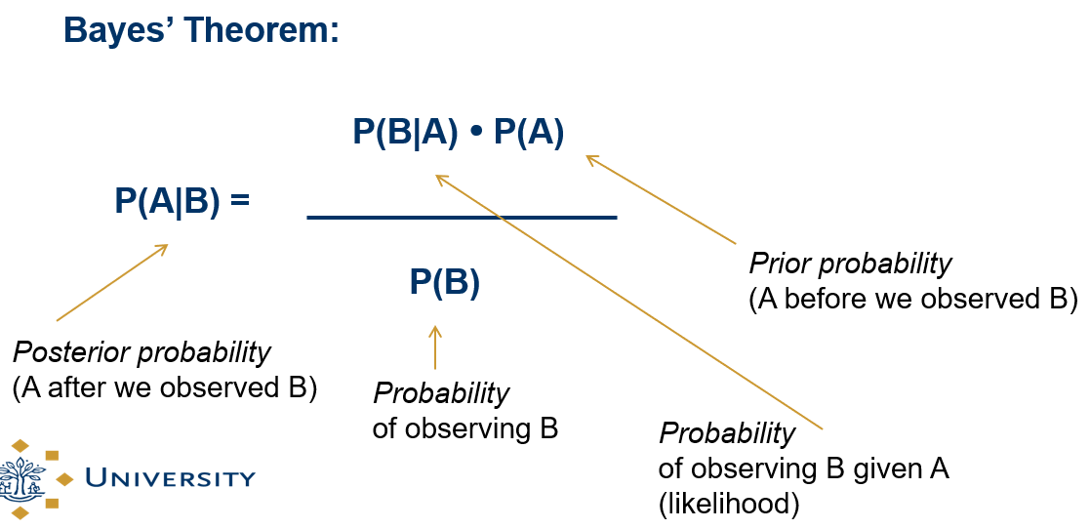

### VISION→→→

### Fovea

* + **The area of the retina with the highest resolution and the highest concentration of cones for detecting colour.** The visual cortex receives information from the retinae of the eyes, via a number of staging posts. The light energy entering the eye activates millions of neuron-like light-sensitive cells, which are the light receptors for vision lining the retina. There are two main types of cells, **rods and cones**. **Cones provide colour vision** and are most dense on the fovea, which is the part of the retina over which vision is most acute. **Rods are more sensitive to light** and are present not only on the fovea, but also in the less acute peripheral areas of the retina.

### Space constancy (vision)

* Objects appear at different retinal locations after eye movements but are **not perceived as displaced**. That means the brain remembers where objects are and were (makes mental visualisation of the world) and can calculate the respective location of the objects by taking the differences into account with regards to **eg** eye movement

### Phenomenal stability (vision)

* Visual input is discontinuous yet we experience no sensation of movement or displacement…
* saccadic suppression’ (masking)

### Saccade

* + Saccades are darting movement of our eyes from one location to another; ca. 3 times/sec
  + Saccades are **Followed by short periods of fixations**; movements during which we obtain information about the world(from the fovea - blind vlek)

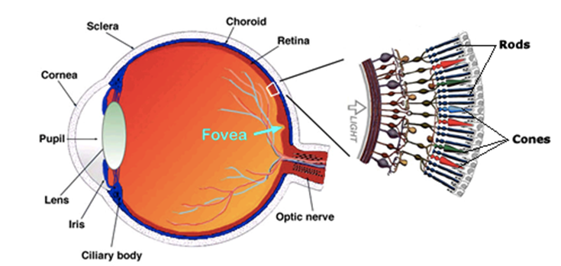

### Saccadic suppression

Saccadic suppression is the phenomenon in visual perception where **the brain selectively blocks** visual processing during eye movements in such a way **that large changes in object location in the visual scene during a saccade or blink are not detected.**

### Rubber Hand Illusion

* + The illusion of owning either a part of or an entire body other than one’s own
  + By manipulating visual perception, bottom-up perceptual mechanisms can override top-down knowledge that a certain body part does not belong to the person

### Acoustic signal

* + An Acoustic signal is a sound pattern of frequency and amplitude **detected by the auditory system**. Phonemes stand for specific sounds, and these sounds are different because they are made up from a particular pattern of frequencies and amplitudes called the acoustic signal.

### Fixation

* + Eye focus movement during which we obtain information about the world
  + Maintianing visual gaze on a single location
    - Visual gaze as in maintain object of interest within focal point of eyes(which would be the fovea)
  + 

### Exteroceptive senses

* + Touch
  + Sense involved on the surface of the body to obtain external information
    - e.g. pressure, touch, heat

### Corollary discharge

* + A copy of a motor command that is sent to the muscles to produce a movement. This copy doesn’t produce any movement istself but is send to the brain to inform it of the impending movement

### Complex tone

* + Any sound composed of more than one sinusoi(pure tone). Harmonic complex tones consist of a fundamental frequency(F0) and harmonics with frequencies at integer multiples of the F0.

### Chemoreceptive senses

* + Smell(olfactory receptors) and taste(gustatory receptors)
  + Sensing chemical stimuli
    - Can therefore also be inside the body; e.g. the stomach sensing fat

### Teloreceptive senses

* + Vision and hearing
  + Sensing from a distance

### Proprioceptive senses

* + Limb position
  + Sense of self-movement and body position
  + Types:
    - Muscle spindles - in muscle fibers
    - Golgi tendon organs - in interface of muscles and tendons/sinew
    - Joint receptors - in joints

### Acoustic feature

* + Any kind of perceptual characteristic which can be ascribed to a particular sound like: pitch, volume, timbre.
  + any acoustic property of  speech sound that may be recorded and analyzed, as its fundamental frequency for formant structure.

## Memory

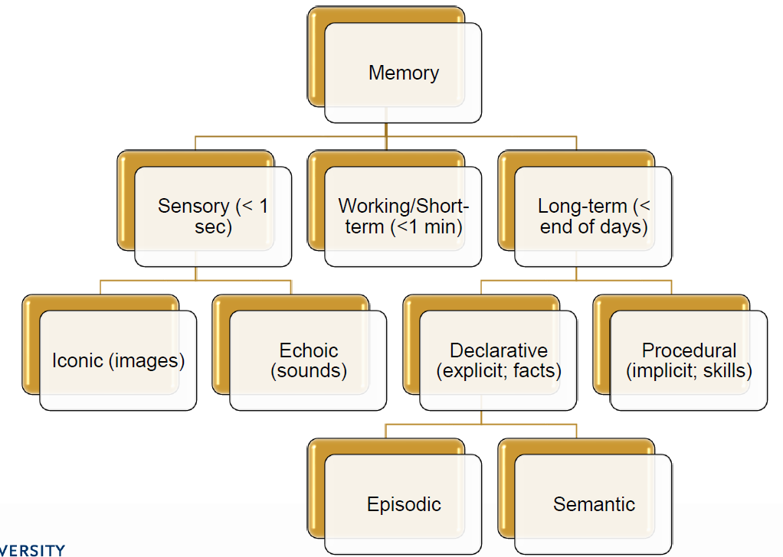

### Sensory Memory

* + Memory that preserves the characteristics of a particular sensory modality: the way an object looks, sounds, feels, etc.
  + Large capacity and short duration (cmp. Working Memory - more persistent but limited to a few items)
  + Info types
    - Echoic: linguistic information
    - Iconic: images

### Short term memory

* + Also called Working memory
  + Different definitions:
    - The manipulation and use of information to guide behavior
    - Working memory involves the process of active maintenance of a limited amount of information
    - A hypothetical cognitive system responsible for providing access to information required for ongoing cognitive processes
    - Working memory subsumes the capability to memorize, retrieve and utilize information for a limited period of time
    - A mechanism that keeps a small amount of information that is particularly task-relevant in a privileged state from which it can be accessed easily.
    - 2 different models:
      * Slot model
      * Resource model

#### Baddeley's model of working memory

* + The original model of Baddeley & Hitch was composed of three main components;
  + the central executive which acts as supervisory system and controls the flow of information from and to its slave systems:
  + the phonological loop stores verbal content
  + the visuo-spatial sketchpad caters to visuo-spatial data.
  + Both the slave systems only function as short-term storage centers.
  + the episodic buffer

##### Central executive

* + Most important component of working memory
  + Has limited capacity, deals with demanding cognitive tasks, resembles attention
  + Is related to executive processes (link to executive functions)
  + Functions:
    - Focusing attention or concentration
    - Dividing attention between two stimulus streams
    - Switching attention between tasks
    - Interfacing with long -term memory

##### Phonological loop

* + A component of Baddeley and Hitch’s (1974) model of working memory, comprising a phonological store and articulatory loop. Responsible for maintaining short-term verbal information.

##### Visual-spatial sketch pad

The visuospatial sketchpad is a component of of Baddeley and Hitch’s (1974) working memory model that holds visuo-spatial information necessary for manipulating images and predominantly spatial information.

visuospatial -- Visuo=Vision & Spatial=pertaining to space

adjectivePSYCHOLOGY

relating to or denoting the visual perception of the spatial relationships of objects.

##### Episodic buffer

* + The episodic buffer has the effect of integrating, or binding together, information from a variety of sources. It is controlled by the central executive, which can retrieve information from the episodic buffer into conscious awareness.

### Long-term memory

* + Storage of information of a long time; little decay and seemingly unlimited amount of information

#### Implicit memory

* + Memory that cannot be explicitly reported, but can be demonstrated to exist by the performance of a task. Memory that a person does not have conscious access to.

#### Procedural memory

* + Anderson (1983) developed a computer model called ACT*. Procedural memory, as in ACT* is usually limited to motor and mental skills, which run off automatically without the need for attention or conscious awareness of the knowledge being used

#### Declarative memory

* + Information that can be retrieved from the long-term memory into conscious awareness, and verbalized.

##### Semantic memory

* + for facts, general knowledge, language.
  + Unrelated to personal experiences

##### Episodic memory

* + Memory of personal experiences
  + Has context related to it
  + In contrast with semantic, which is unrelated to personal experiences and pure factual

### Familiarity

* + With regards to long-term memory
  + Observer knowing an item is old or new, without having specific details associated with that memory; the process of recognizing an item on the basis of its perceived memory strength but without retrieval of any specific details about the study episode

### Feeling of knowing

* + A term introduced by Huppert and Piercy (1976) for the effect observed in patients with amnesia who did not recognise a stimulus as having been seen before, but had a less definite feeling that they knew it in some way

### Recollection

* + Observer accessing specific details about a previously experienced item

### Metamemory

* + Knowing what we know
    - “I know that I know the name of that person or city”
      * “But, right now I just forgot it”
    - Could be triggered by a particular cue

### Cued recall

* + Provides a cue to recall a certain piece of information
    - E.G.( Taking an exam in the same room you studied would probably help you, as you use cues in the room during studying that you could use during the exam

### Serial position curve (memory)

* + When a list of words that must be remembered is longer than that which can be held in short-term memory, the first and last items in the list are more accurately recalled than items from the middle of the list.

### Primacy effect (memory)

* + The recall advantage for the first few items in a list. Part of the serial position curve.

### Recency effect (memory)

* + The report advantage of the most recently presented items in a list.

### Reinforcement Learning

* + Connecting a reward(positive feeling, e.g. Joy) or a penalty(negative feeling, e.g. Pain) event to a precuring sequence of actions/events.
    - e.g.
      * Put pan on hot stove, touch hot pan with bare hands → pain → next time use gloves
      * Feel tired, pay attention to lecture draining more energy, drink double espresso → Feel more energized and happy → next time drink coffee in break lecture again

### Amnesia

* + Deficit in memory caused by brain damage, disease, or psychological trauma. Can also be temporarily caused by sedatives and hypnotic drugs.
  + Memory can either be wholly or partially lost.
    - Retrograde Amnesia
      * not able to retrieve information before a particular date/event
    - Anterograde Amnesia
      * inability to transfer new information from the short-term memory into the long-term memory

### State dependency (memory)

* + When material is learned in a particular mood or physiological state, memory performance is best when the participant is in the same state at recall.

### Type I processing (memory)

* + One of the types of rehearsal in the levels of processing approach, in which information is recirculated at the same level with no additional processing for depth.

### Type II processing (memory)

* + According the levels of processing approach, this type involves recoding of information to another level of depth and leads to a more durable memory trace.

### False memories[5]

* + Johnson et al. (1979) showed that thinking about or imagining words increased the likelihood that people thought they had actually seen those words. It could be that imagination can lead to false childhood memories, or that imagination actually triggers recall of a real event.

## (Brain) anotomy

**Anatomical terms of location**

[Link](https://en.wikipedia.org/wiki/Anatomical_terms_of_location#Main_terms) to wiki

Dorsal:

The dorsal (from Latin dorsum, meaning 'back') surface of an organism refers to **the back**, or **upper side**, of an organism. If talking about the skull, the dorsal side is the top. ( **Some people will use the phrase "back of my hand" to refer to that surface**

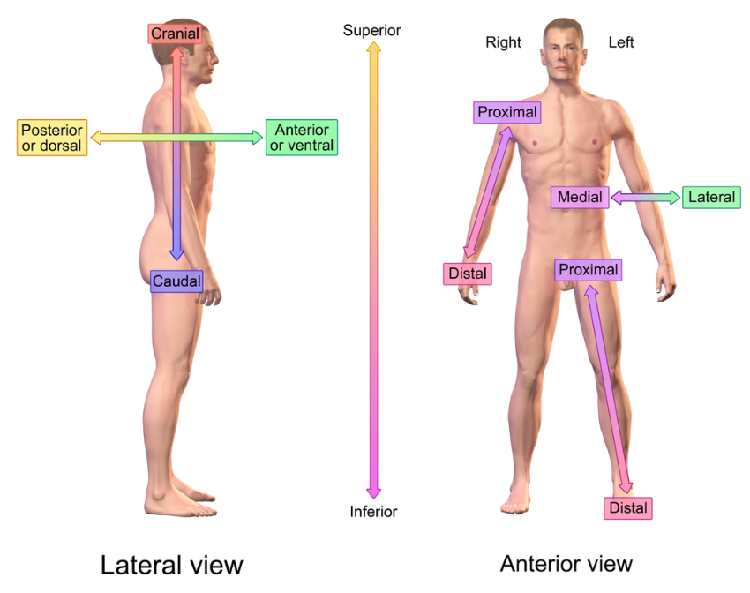Confusion regarding dorsal:

there are two primary anatomical meanings of "dorsal". The less-common usage is that it can refer to the **back of your hand or the top of your foot** (the 'unused' side, if you will; or the "back side" of it, which is where the usage comes from); the more-common usage is that it **refers to the body surface closest to your spine**. (For humans, the back; for fish, the top. A fish's "dorsal fin" is the one on its top.)

### [Link](https://youtu.be/q8NtmDrb_qo?t=348) to CC video on CNS (from limbic system on)

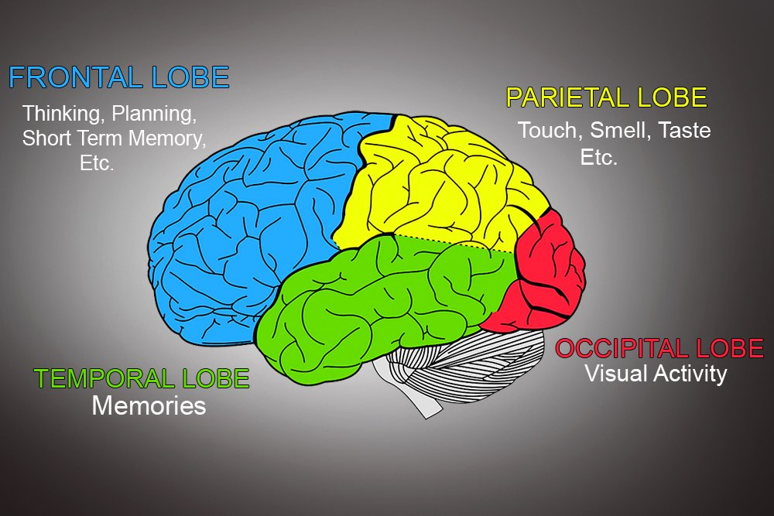

### The Cerebrum →

* + That walnut thing, that we conceive of when we think about “the human brain”
  + It’s has 2 hemisheres, each has 4 lobes:
  + It is not “the only part”of the brain ↓

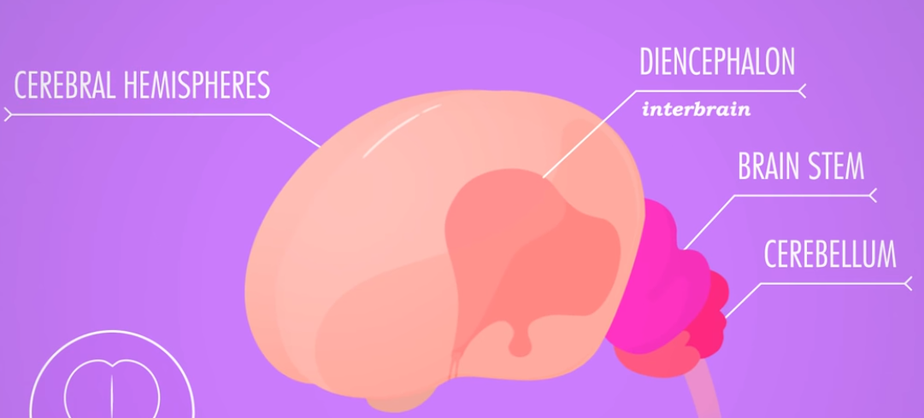

* + That most lower thing is the spinal cord ↑

### Frontal lobe

* + The largest of the 4 major lobes of the brain in mammals, located near the forehead

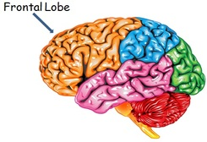

#### Prefrontal cortex[6]

* + planning complex cognitive behavior, personality expression, decision making, and moderating social behavior.[3] The basic activity of this brain region is considered to be orchestration of **thoughts and actions in accordance with internal goals**
  + PFC is the cerebral cortex which covers the front part of the frontal lobe.
  + 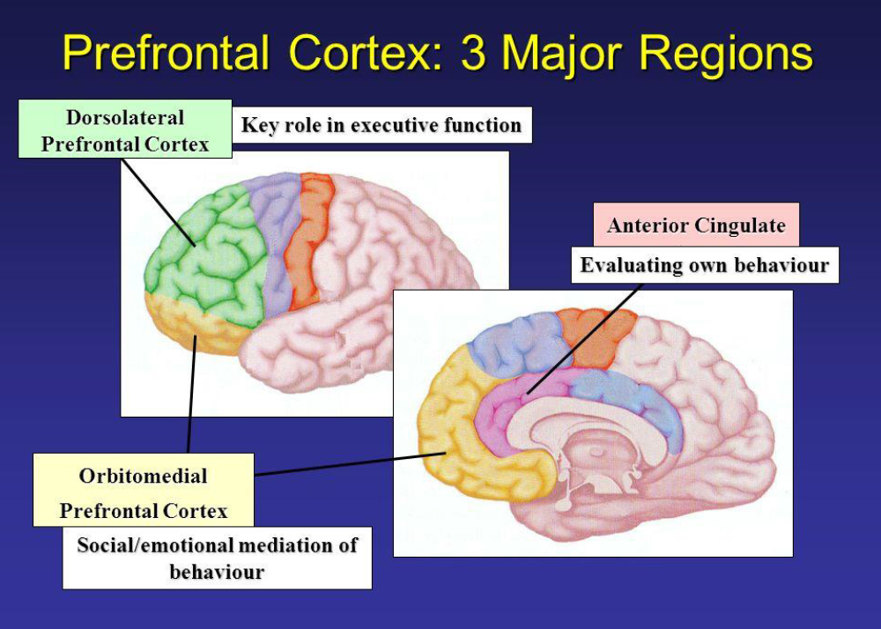The most typical psychological term for functions carried out by the PFC is **executive function**.
    - relates to abilities to differentiate among conflicting thoughts, determine good and bad, better and best, same and different, future consequences of current activities, working toward a defined goal, prediction of outcomes, expectation based on actions, and social "control"
  + Doesn’t stop evolving in humans up until approximately when they are [25 years of age](https://www.urmc.rochester.edu/encyclopedia/content.aspx?ContentTypeID=1&ContentID=3051) and is the part of the brain that is most suscectible by experience (rather than genes)

### Temporal lobe

* + Involved in processing sensory input into derived meanings for the appropriate retention of visual memory, language, comprehension and emotion association
  + Consists of structures which are vital for declarative of long-term memory.

### Occipital lobe

* + Contains visually driven regions
    - I.E.( when you enjoy a nice sunset, thank your occipital lobe
  + One of the four major lobes of cerebral cortex in mammalian brains

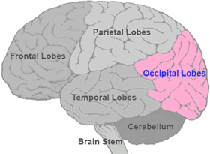

### Parietal lobe

* + Integrates and processes sensory information among various modalities, such as
    - spatial sense & navigation
    - mechanoreception (sense of touch)
    - Somatosensory cortex
    - Language processing
  + Its function also includes processing information relating to the sense of touch

### The Limbic system

* + It supports a variety of functions including emotion, behavior, motivation, long-term memory, and olfaction.[2] Emotional life is largely housed in the limbic system, and it critically aids the formation of memories.
  + A.k.a. “the reptilian brain”

#### Thalamus

* + 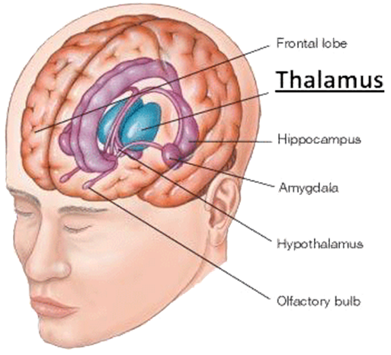Central place in brain; integrates and transmits information → data center
    - Can connect sensory input to a related meaning like an emotional event
      * Smell cigars, think of grandpa
    - Regulation of consiousness, sleep and alertness
    - Transmitting motor signals
  + There are thalamic nuclei for every sensory signal
    - Thalamus receives sensory signals and sends them to the appropriate cortical area
      * Can also suppress sensory signals if needed
    - Exception: olfactory senses don't traverse Thalamus
  + Thalamus interacts with the PFC in attentional processes

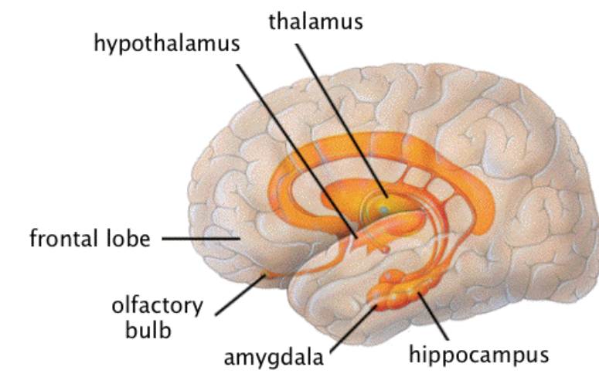

### Primary auditory cortex

* + Identifies fundamental elements of sound, such a pitch and loudness, and sends them on for further processing/classification/analysis
  + Tonotopically organized: neighboring cells in the cortex respond to neighboring frequencies
  + Located in the superior temporal gyrus of the temporal lobe, the primary auditory cortex extends into the lateral sulcus and the transverse temporal gyri
  + 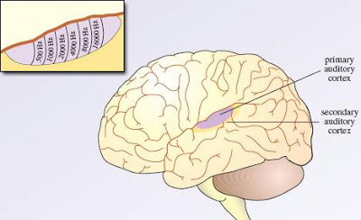
  + However, we’re not completely that sure:
    - “Three major implications of the paradigm-changing findings reviewed above are considered: (1) the attribution of meaning to sound; (2) reconceptualization of the primary auditory cortex and, by extension, (3) the need for a new model for the entire cerebral cortex.”
      * R.L. Jenison, in International Encyclopedia of the Social & Behavioral Sciences, 2001

### Cochlea

* + The little snails living inside your ears
  + The spiral-shaped structure of the inner ear, which is divided along its length by the basilar membrane.
  + 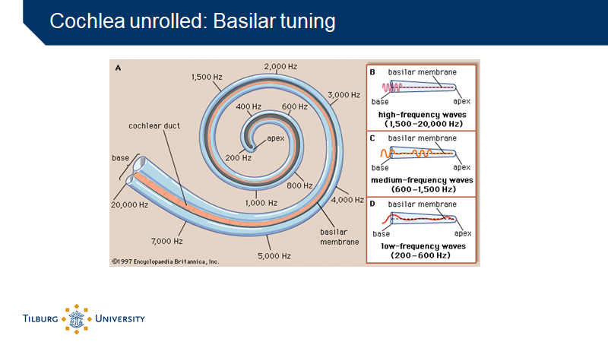

### Retina

* + The innermost, light sensitive layer of tissue of the eye.
  + Creates a focused two-dimensional image of the visual world by receiving light and translating that image into electrical neural impulses which are send to the brain to create visual perception
  + Simmilar to the film or image sensor in a camera

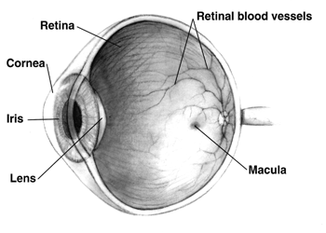

### Blind spot

* + The place where the optic nerve leaves the back of the eye. At this point the retina effectively has a ‘hole’ in it, and so no visual information is coded over this area.

### Basilar membrane

* + Stiff structural element that seperates two liqued filled tubes that run along the coil of the cochlea, the scale media and the scale tympani
  + Located in cochlea
  + 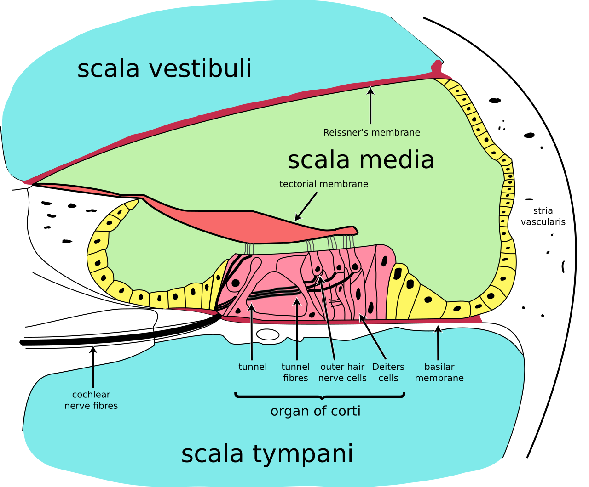

# Concepts from papers

## Executive functions

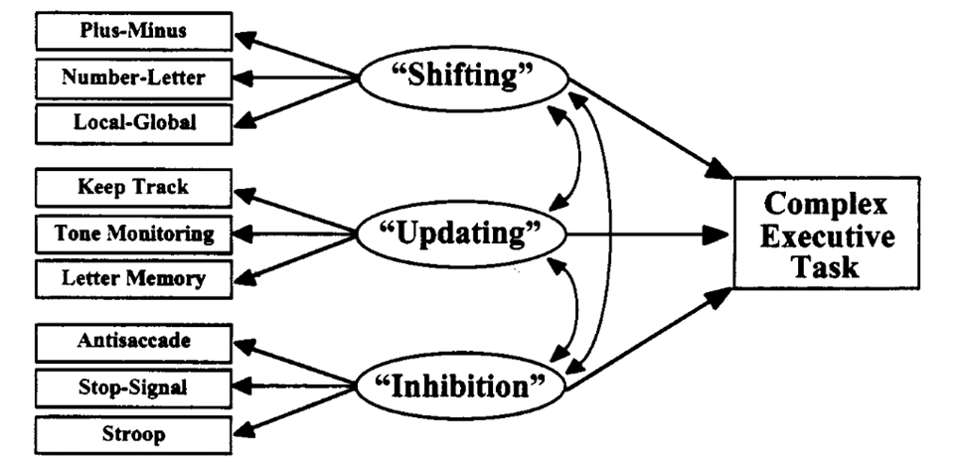

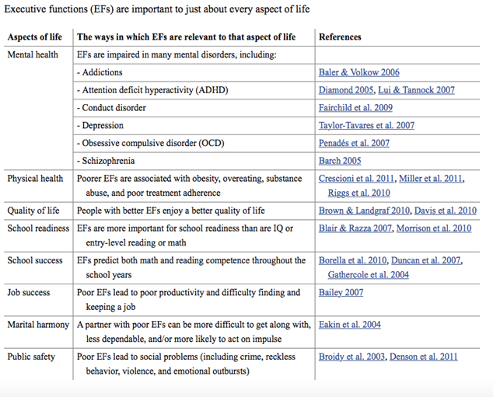

#### Shifting

* + Official: shifting between tasks of mental sets
  + shifting your attention from one object of focus(externally or internally) to another object of focus
  + see 43 for image

#### Updating

* + Updating and monitoring of working memory representation
    - Also actively manipulation information in the working memory
    - E.g. “Ah Jos is not 25 years old but 28 and he comes from Limburg, but more specifically from Arcen”

#### Inhibition

* + inhibition of prepotent responses
  + The ability to overriding/blocking/restraining the tendency to produce a more dominant or automatic response, behaviour, desire or impulse
    - e.g.
      * Top-down cognitive process: If I don’t have anything to do, I automatically grab my phone, even if I already looked at it 5 minutes ago, to look for new messages/updates but I know that this behaviour is prone to create anxiety so often I inhibit that tendency by meditating on my breath and reflecting on my desire to look on my phone as unnecessary and unproductive
      * Emotional response: a feeling of embarrassment or worry that prevents you from saying or doing what you want is also a form of inhibition
      * Mindfulness is a form of inhibition

## Metacognition , dup

* + Metacognition involves Cognitive processes about other cognitive processes; E.G.( knowing about knowing, beliefs about beliefs).
  + Collection of 2nd order representation that allow for the monitoring of first order representations concerning objects/events in the world. In **perception**, metacognitive research investigates whether observers can access their uncertainty about the perceptual represenations that are formed on the basis of noisy sensory evidence.
  + Monitoring one's uncertainties concering the final integrated percept & the individual sensory signals & the world's causal structure

## Active sampling (attention)

* Attention is closely related to **decision-making**. In ecologically valid situations, humans are engaged in active sampling in coordination with beliefs, goals or actions. There are two important components of the process:
  + Deciding which **cue is task-relevant** and should be sampled (~information gain/reduction of uncertainty)
  + Deciding which action to take based on that cue (~**reward**).
* Gottlieb’s decision chain depicts the **sequential decision**-making process using the example of crossing the road.
  + The first decision concerns which **sensory** input to select as **relevant**(the traffic light or the cloud), followed by the decision of which **action to take**, given the likely outcome and the **reward** associated with it.

R = red b = blue

G – green w = white

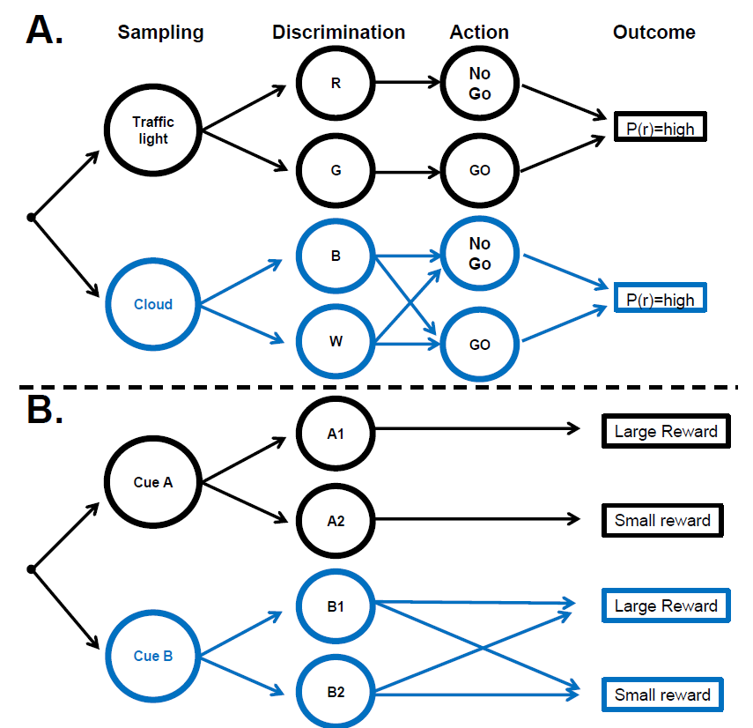Fig. 1: Decision chains for sampling and actions.

(A) Instrumental[7] sampling[8]: the agent makes a decision of which cue to sample (“**Sampling**”), discriminates the properties of the selected cue (“**Discrimination**”), decides which action to take based on the discrimination (“**Action**”) and realizes an outcome (“**Outcome”, or reward**, r) with probability (P(r)). In the specific example, a pedestrian decides whether to **look** at a traffic light or a cloud, **discriminates** the colors of the sampled stimuli (red/green for the light and blue/white for the cloud), and takes the **decision** to stop or proceed (NoGo/Go) in order to be safe (**reward**, r). The Shannon **entropy** of the possible actions is high before sampling either cue as well as after sampling the cloud (1 bit if the Go/NoGo actions are equally likely) but becomes much lower depending on the reliability of the cue (e.g, 0 if the cue produces perfect certainty about the optimal action).

(B) Non-Instrumental Sampling: The cues indicate a preordained[9] outcome but the agent cannot alter the outcome. The agent makes the decision whether to sample cue A or B, and discriminates the signal given by the sampled cue. Signals A1 and A2, produced by sampling cue A, predict with certainty whether the reward will be large or small. Signals B1 and B2, produced by cue B are random and do not reduce the uncertainty about reward size.

Concerning B:

Cue a ; informative cue

Cue b ; uninformative cue (the cue could lead to either large or small reward)

No “action” ; just cue and a predetermined outcome

Concerning A:

Goals (top down) guides people sampling of cues, as specific cues maximize the probability of rewards

A ; cues that guide agen’t actions, which can lead to a certain reward

B; cues that only predict a certain probability of reward but, these cues cannot guide the agen’t action, as the reward

Is already predetermined

Fun fact: The monkeys tested under B (non instrumental sampling eximeriment) developed a consistent preference for the informative cues

They were willing to sacrifice juice reward, to attend to predictive cues

## Ensemble perception

* + The visual system’s ability to detect and extract information from groups of similar objects (faces, trees, cars, …) that is statistically representative of the whole group, such as motion, orientation, brightness, hue and social position
  + Relation is holistic; belief/feeling that they are (intimately) connected, looking at the whole (group)
  + e.g.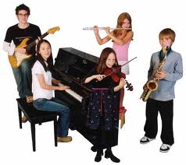
    - Perception: an ensemble of 5 kids, average hobby: music, average style: unfashionable, average posture: faked active playing, average gaze: gaze focussed on camera
  + Reality has a lot of information, and our capacity of **visual system Is limited**.
  + although natural scenes are dense with information, this clutter is not completely random. Instead, **natural scenes are filled with similar or redundant groups** of objects, features, and textures. The visual system is sensitive to these similarities
  + probably why ensemble perception is a thing
  + Ensemble perception mainly expresses in **averages**
  + Ensemble percepts occur across 5 levels of visual analysis:
  + Low level ensemble perception
  + E.G.( Motion, brightness, hue, etc.
  + Mid level..
  + E.G.( average size of circels)
  + High level
  + E.G.( evaluate and discriminate the average emotional expression and gender in a crowd
  + Multiple ensembles
  + Research suggest that people can extract multiple ensemble characteristics from one or more groups of stimiuli
  + studies have shown that observers can successfully extract multiple ensembles from up to four groups of stimuli
  + Forms of ensemble represenations
  + The most common one is **average**
  + **Variance** is also a noteworthy one:
  + E.g.: when walking through a crowd of people, the average emotion is in formative, but equally critical is the variation of emotion present in the crowd

## Short term memory ; slot model vs equal resource model

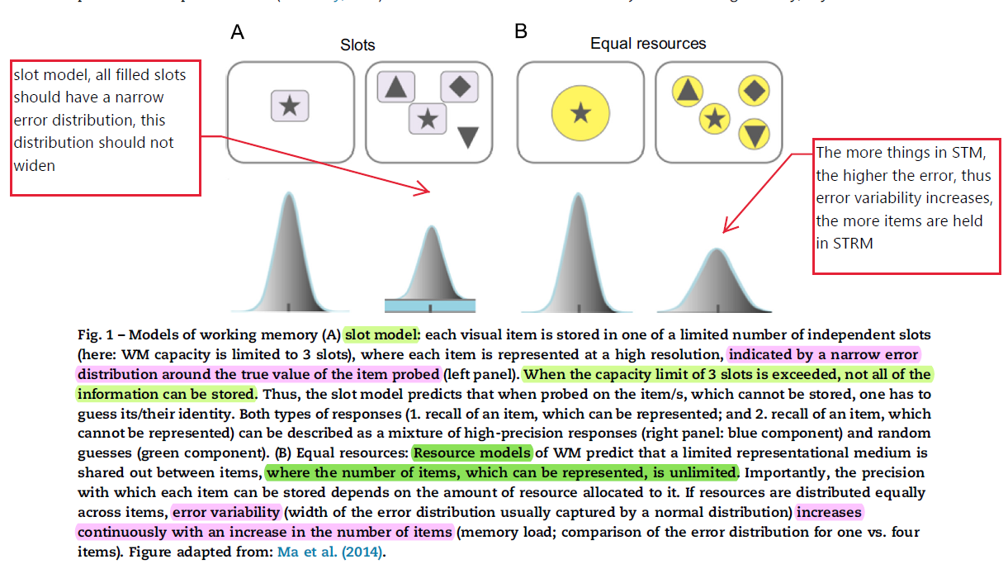

## Familiarity vs recollection ; dpsd and cdp models

Lead up to familiarity and recollection:

1. VLTM ; Visual episodic long term memory
2. VWM; Visual working memory

VLTM must manage between tolerance and discrimination. This is the function of VLTM—to manage this tension in order to recognize a previ ous visual experience given new input.

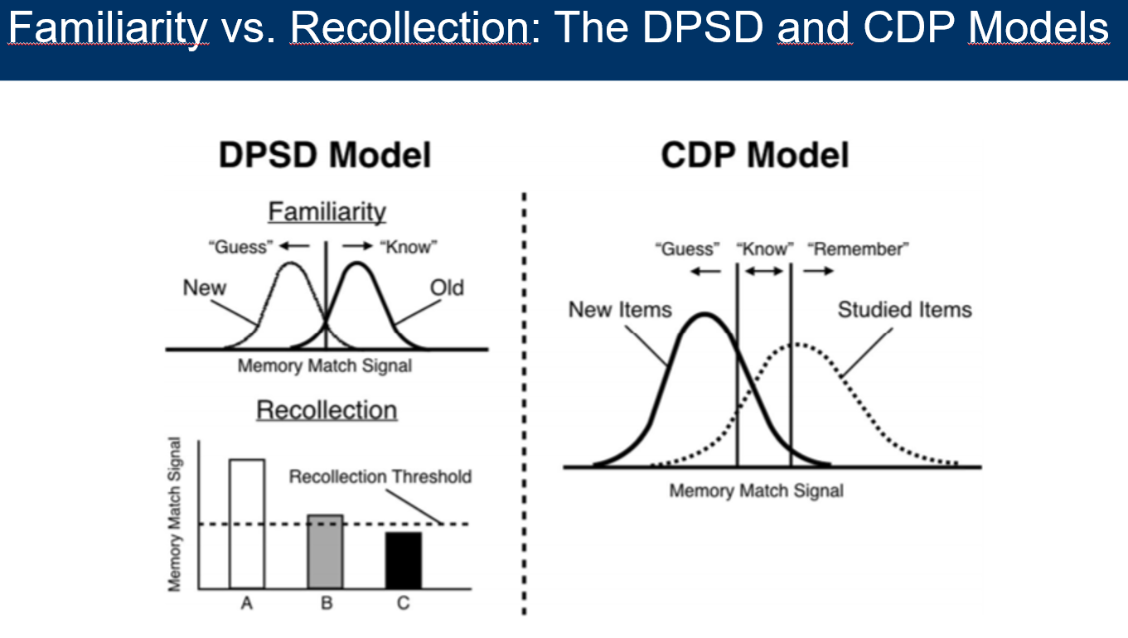

Fig. 1

Illustration of the **dual-**process signal-detection (DPSD) and **continuous** dual-process (CDP) models.

In the **DPSD dual process model**, familiarity and recollection are dual: two **distinct** but **parallel**[10] processes. Familiarity is a signal-detection process of discriminating between two Gaussian distributions/normal distribution between **old** and **new** items, where familiarity occurs when the signal exceeds a decision criterion (i.e., participants “know” they saw the item). Recollection is a threshold-based process where signal strength passes a certain threshold and is either recollected or not. In the diagram, **both Stimuli A and B pass the threshold** and would thus be **recollected** with the **same amount of detail**, regardless that each stimulus may illicit different amounts of memory-match signal strength. Stimuli C does not pass the threshold and would thus not be recollected.

In the **CDP model**, both familiarity and recollection vary continuously and operate using signal-detection-based processes. These **processes are interactive** and are combined during decision-making, resulting in **a single distribution** for studied items. In the simplest version of the model, familiarity occurs when the memory-match signal exceeds a lower decision criterion (i.e., “know”), whereas recollection occurs when the signal exceeds a higher decision criterion (i.e., participants “remember” the details of the item)

<https://link.springer.com/article/10.3758/s13414-018-1522-y>

Main takeaways:

* For DPSD recollection = **threshold** based, conversely: for CPD both familiarity (know) & recollection (remember) are **continuous**
* In the CPD model: familiarity and recollection are **interactive**; “guess, know and recollection/remember” are same curve so knowing should aid recollection
* Difference when it comes to New and Old memories

## the hippocampus and recollective memory organization

Eichenbaum 2017

Summary:

How does the brain organize memories? What is the role of the hippocampus and PFC? Experimental studies were hippo damaged ratsperform memory task, to look at the role of the hippo.

HIPPOCAMPUS ORGANIZATION

:

:

ASSOCIATIVE ORGANIZATION

=

-multiple events are linked by direct and indirect associations within a network

- Hippocampus damage causes recollection performance impairment

SEQUENTIAL ORGANIZATION

=

-related to EPISODIC memory;involving TEMPORAL org. of serial events

-Damage hippocampus causes EPISODIC MEMORY to be severely impaired (even when SEMANTIC memory is relatively intact) ; subjects succeed to remember individual items, but not the order in which they appear (temporal aspect)

SCHEMATIC ORGANIZATION

=

-hierarchical organization of items

-factual knowledge/SEMANTIC MEMORY is embedded within schematic organizations.

-hippocamus damage subjects can learn two unambiguous pairs (eg a over b, b over c) but not the full set, which requires a circular schematic organization (a over c, when that combi is not explicitly learned)

Mandler’s 3 organization structure in Eichenbaum:

* + Associative organization

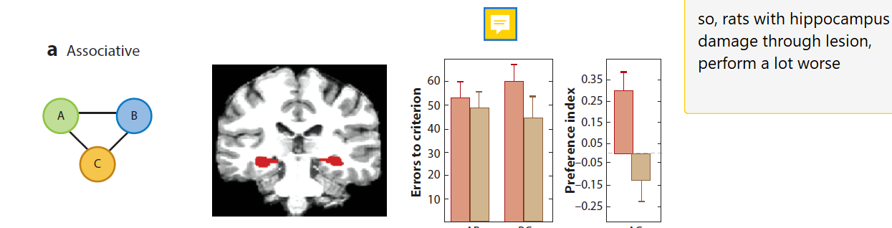

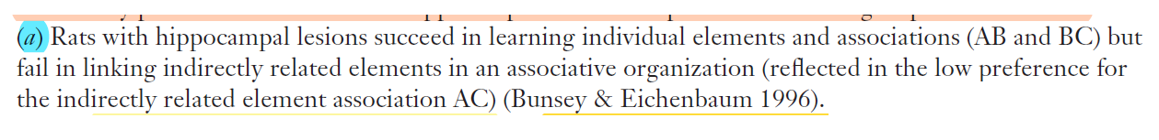

* + Sequential organization

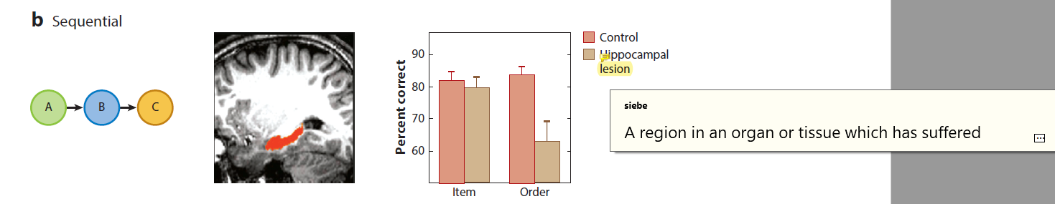

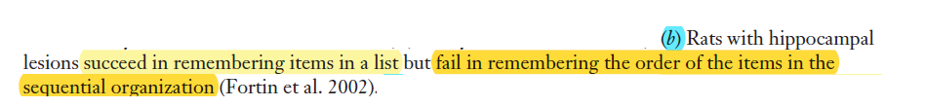

* + 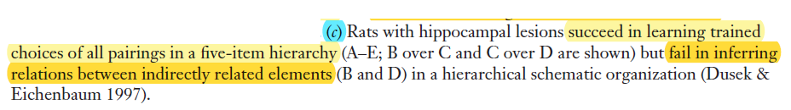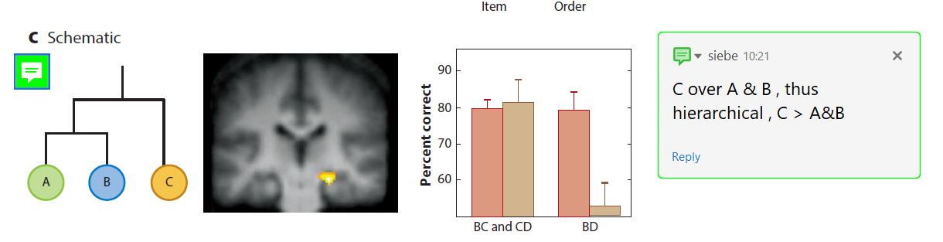Schematic organization
  + So with hippo damage: can learn C>B>A ; but then havent learned that C>A (even though it should be implicitly learned)

# Pop quizzes

### Difference in mechanism between visual auditory attention

Is there any difference between the mechanism of visual and auditory attention? Motivate your answer.

* + There is a fundamental difference between visual and auditory attention that has to do with the perceptual process of visual stimuli and auditory stimuli.

1. While we can **actively select** which **visual stimuli** we focus on and which visual input we exclude (we can steer our gaze direction with the movement of our eyes/head/body and, if need be, we can close our eyes).
2. That is not possible for **auditory stimuli** where the selection of relevant input needs to be done by different mechanisms. The added challenge is that auditory stimuli are **transient in time**.

### Active sampling

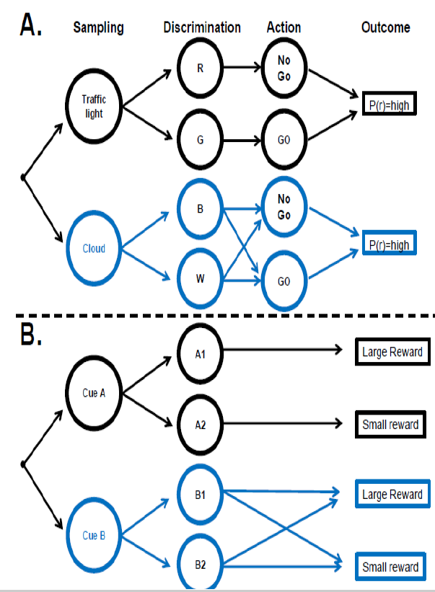What is understood under the term ‘active sampling strategy’ as discussed by Gottlieb (2018)? In your answer, include a figure depicting Gottlieb’s representation of decision chains for sampling and action.

* + Attention is closely related to decision-making. In ecologically valid situations, humans are engaged in active sampling in coordination with beliefs, goals or actions. There are two important components of the process:
  + **A** deciding which **cue is task-relevant** and should be sampled (~**information gain**), and
  + **B** the decision of which action to take based on that cue (~**reward**). Gottlieb’s decision chain depicts the sequential decision using the example of crossing the road (goal). The first decision concerns which sensory input to select as relevant (the traffic light or the cloud), followed by the decision of which action to take, given the likely outcome and the reward associated with it.

### Hubel and wiesel

For which discovery did Hubel and Wiesel receive the Nobel prize?

* + recording the activity of cell in the visual cortex of cats. They found, that the cells are [selectively responsive to lines of different orientations or moving in particular directions](https://youtu.be/RPv0a9ftu6Y?t=8).

### Pitch

* + What is pitch?
  + Pitch is the perceptual property in the human mind of what is induced by the frequency of a sound wave. For humans, it is an important source of information about a speaker’s age, gender and expected size.

### Metacognition , dup 2

* + What is Metacognition
  + Cognitive processe about other cognitive processes; E.G.( knowing about knowing, beliefs about beliefs). Collection of 2nd order representation that allow for the monitoring of first order representations concerning objects/events in the world. In **perception**, metacognitive research investigates whether observers can access their uncertainty about the perceptual represenations that are formed on the basis of noisy sensory evidence.

### Executive functions

* Q1: To what extent can different functions often attributed to the frontal lobes be considered unitary in the sense that they are reflections of the same underlying mechanism or ability?
  + As reported in the influential paper by Miyake et al. (2000), different executive tasks moderately correlate in individual performance but are clearly statistically separable. The executive tasks are: **shifting, updating/monitoring and inhibition**.

### Phonological Loop and the VSSP

**Q2: How is auditory and visual working memory distinguished in Baddeley’s model (Baddeley & Hitch, 1974)?**

They are tied to different storage mechanisms: the Phonological Loop and the VSSP (visual-spatial sketchpad).

### What are these Researchers known for?

Hubel and Wiesel

Gotlieb

# Other Interesting information

### The cognitive system schematic

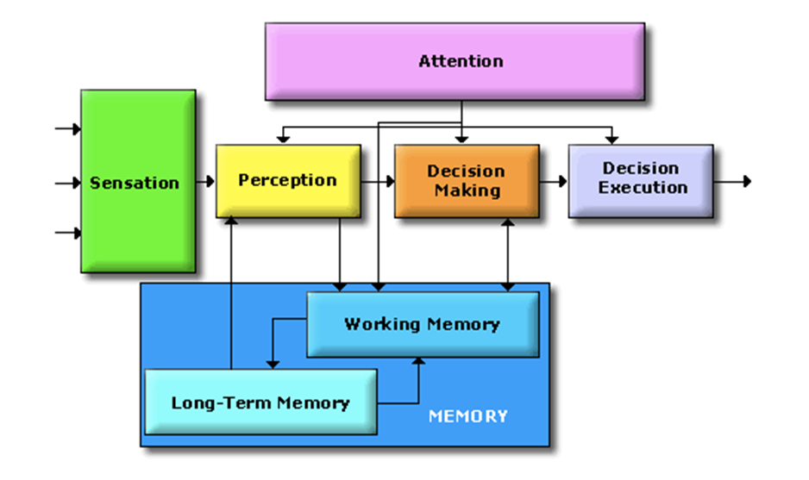

1. Methods utilized to understand the brain by reverse engineering[11]:
   1. Brain imaging techniques
   2. Questionnaires
   3. Behavioural tasks
   4. Lesions?

### Memory stores schematic

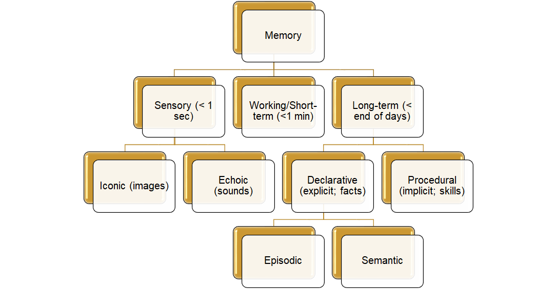

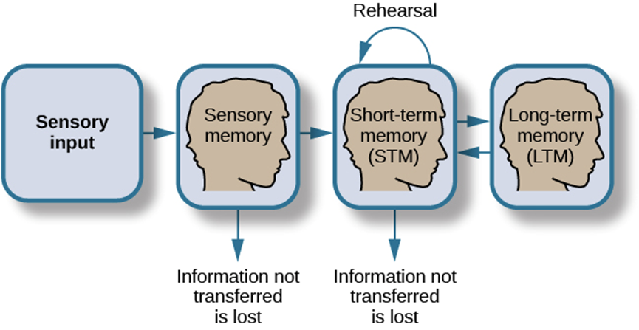

### Immanuel Kant

“I call knowledge transcendental which is occupied not so much with objects, as with our a priori concepts of objects.” 1 —with our modes of correlating our experience into knowledge. There are two grades or stages in this process of working up the raw material of sensation into the finished product of thought.

* The first stage is the coordination of sensations by applying to them the forms of perception—space and time;
* the second stage is the coordination of the perceptions so developed, by applying to them the forms of conception—the “categories” of thought.

Kant, using the word esthetic in its original and etymological sense, as connoting sensation or feeling, calls the study of the first of these stages “Transcendental Esthetic”; and using the word logic as meaning the science of the forms of thought, be calls the study of the second stage “Transcendental Logic.” These are terrible words, which will take meaning as the argument proceeds; once over this hill, the road to Kant will be comparatively clear.

Now just what is meant by **sensations and perceptions**?— and how does the mind change the former into the latter?

By itself a **sensation** is merely the awareness of a stimulus; we have a taste on the tongue, an odor in the nostrils, a sound in the ears, a temperature on the skin, a flash of light on the retina, a pressure on the fingers: it is the raw crude beginning of experience; it is what the infant has in the early days of its groping mental life; it is not yet knowledge. But let these various sensations group themselves about an object in space and time—say this apple; let the odor in the nostrils, and the taste on the tongue, the light on the retina, the shape-revealing pressure on the fingers and the hand, unite and group themselves about this “thing”: and there is now an awareness not so much of a stimulus as of a specific object; there is a **perception**.

Sensation has passed into knowledge.

1. One does register everything and assign meaning to it, but then your selective filter decides what to pass on to the conscious awareness
2. • Modality = Classified single independent sensory input/out channel o e.g. Vision, Audition(hearing - input, voice - output)
3. Arrow by itself is just a collection of lines, our knowledge, however, give it meaning.
4. process
5. Had dit vandaag, zwemdiploma 15 jaar geleden ofzo, mijn oma herrinnerde dit dat zij in haar oog werd gestoken met mijn zwemdiploma door mij, en ik kon niet herinneren dat ik degene was die oma in haar oog prikte; ik dacht dat het iemand ander was die oma in haar oog had gestoken, toen riep mijn moeder: dat deed je ook niet, het was oma die mij in mijn oog prikte.

   Wellicht dat de plausability zo was, dat het logischer was dat ik diengene was die het had gedaan, sinds ik het zwemdiploma had gehaald, en daardoor eerder die in mijn handen zou hebben…
6. uter layer of an organ or structure in plant or animal
7. Serving or acting as a means or aid
8. In conditions where the decision maker can act based on the sampled information
9. Determined beforehand
10. Parallel in the sense they never meet? Why then ‘but’?
11. the process by which a man-made object is **deconstructed** to reveal its designs, architecture, or to extract knowledge from the object; similar to scientific research, the only difference being that scientific research is about a natural phenomenon